Asymmetric Shapes
# Source: AI Source: Provided by: [Data Path: Persons Table -> ID Column: 1, Name_En Column: Motasem Essam] -> From: [ChatGPT] on [7/25/2026]
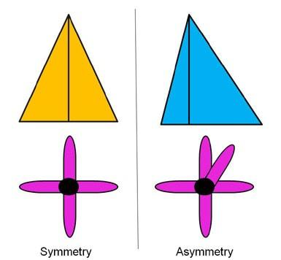
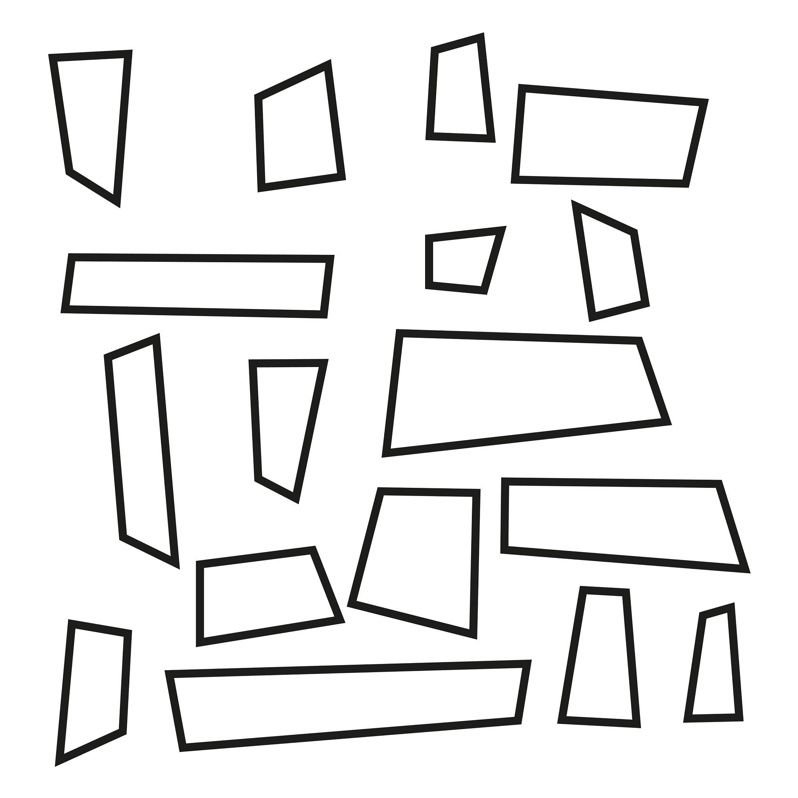
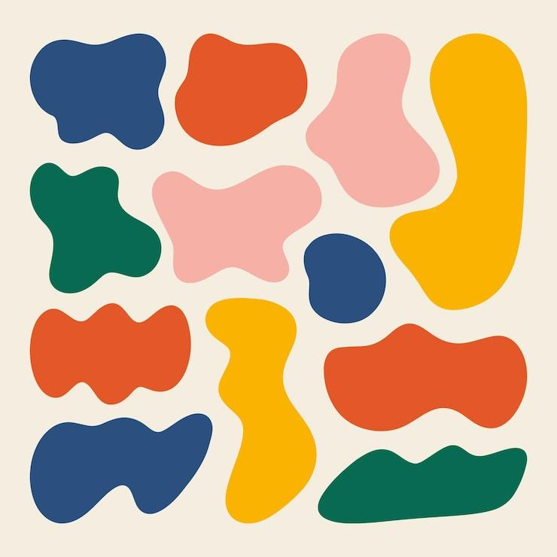
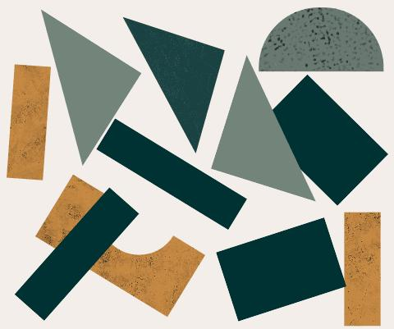
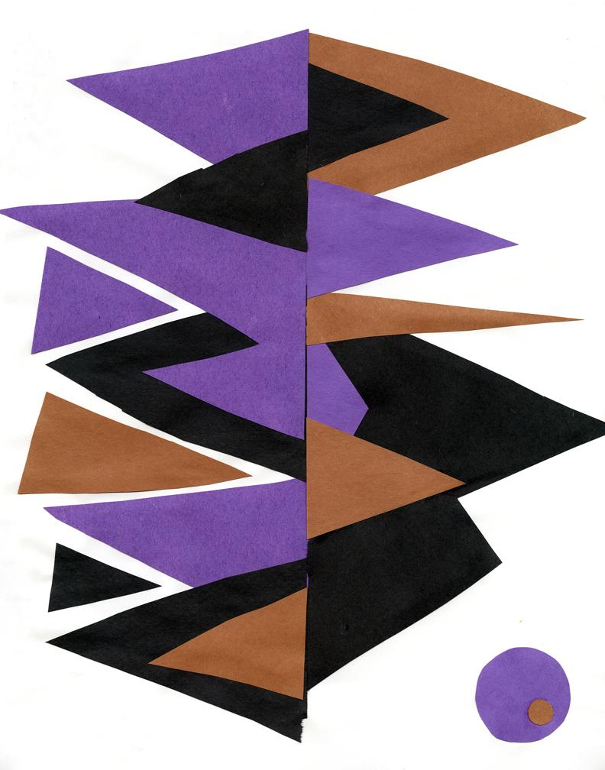

Definition
# Source: AI Source: Provided by: [Data Path: Persons Table -> ID Column: 1, Name_En Column: Motasem Essam] -> From: [ChatGPT] on [7/25/2026]
An Asymmetric Shape is a shape that does not have a specified symmetry. In particular, it does not coincide with itself under the symmetry transformation being considered.
In simple terms, its parts do not form matching mirror-image or rotational patterns.
$$\boxed{\text{Asymmetric Shape}=\text{Shape without the considered symmetry}}$$
For example, an irregular shape with no line of reflection symmetry and no non-trivial rotational symmetry is asymmetric.

Fundamental Concept
# Source: AI Source: Provided by: [Data Path: Persons Table -> ID Column: 1, Name_En Column: Motasem Essam] -> From: [ChatGPT] on [7/25/2026]
Asymmetry is the opposite of symmetry in the relevant sense.
A shape may be tested for:
- Line symmetry
- Rotational symmetry
- Point symmetry
If none of these applicable symmetries exists, the shape is generally described as asymmetric.
However, asymmetry should be stated carefully because a shape may lack one type of symmetry while possessing another.
For example:
- A rectangle has line symmetry.
- A parallelogram generally has no line symmetry.
- A parallelogram does have ${180}^{∘}$rotational symmetry.
Therefore, a shape can be asymmetric with respect to reflection without being completely asymmetric.

Main Characteristics
# Source: AI Source: Provided by: [Data Path: Persons Table -> ID Column: 1, Name_En Column: Motasem Essam] -> From: [ChatGPT] on [7/25/2026]
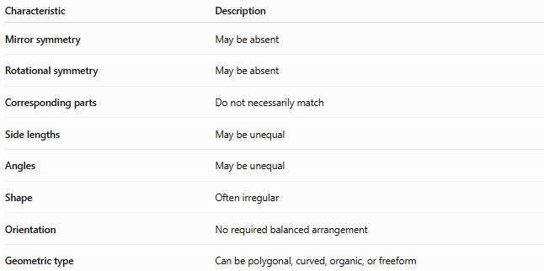
Characteristic | Description
Mirror symmetry | May be absent
Rotational symmetry | May be absent
Corresponding parts | Do not necessarily match
Side lengths | May be unequal
Angles | May be unequal
Shape | Often irregular
Orientation | No required balanced arrangement
Geometric type | Can be polygonal, curved, organic, or freeform

Types of Asymmetric Shapes
# Source: AI Source: Provided by: [Data Path: Persons Table -> ID Column: 1, Name_En Column: Motasem Essam] -> From: [ChatGPT] on [7/25/2026]
A useful classification is:
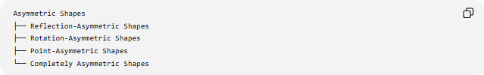
Asymmetric Shapes
├── Reflection-Asymmetric Shapes
├── Rotation-Asymmetric Shapes
├── Point-Asymmetric Shapes
└── Completely Asymmetric Shapes

1-Reflection-Asymmetric Shapes
# Source: AI Source: Provided by: [Data Path: Persons Table -> ID Column: 1, Name_En Column: Motasem Essam] -> From: [ChatGPT] on [7/25/2026]
A shape has reflection asymmetry when it has no line of reflection symmetry.
For example, a general scalene triangle has no line of symmetry.
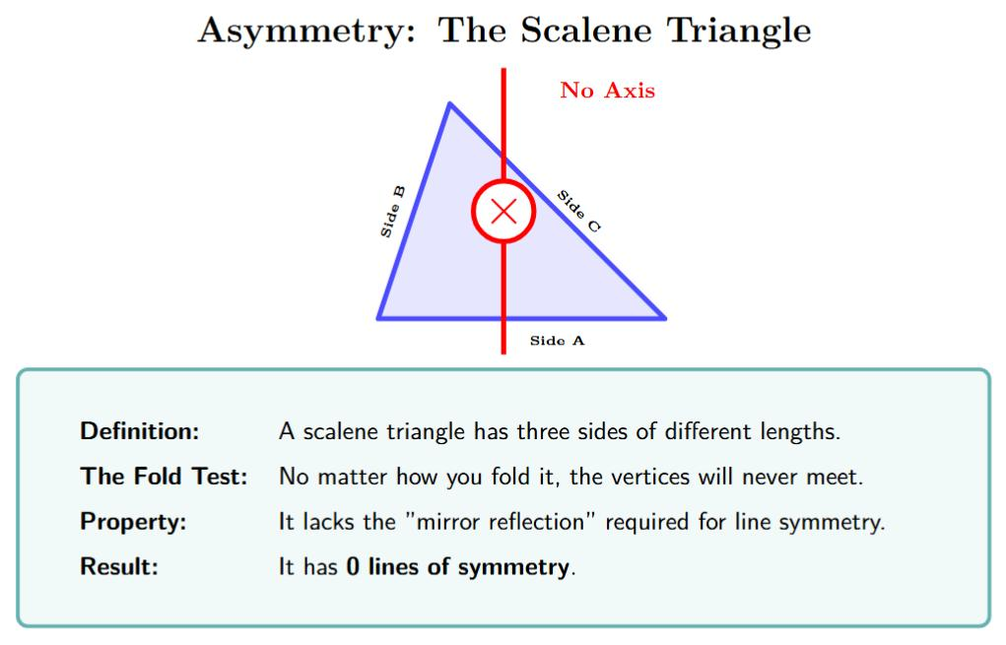
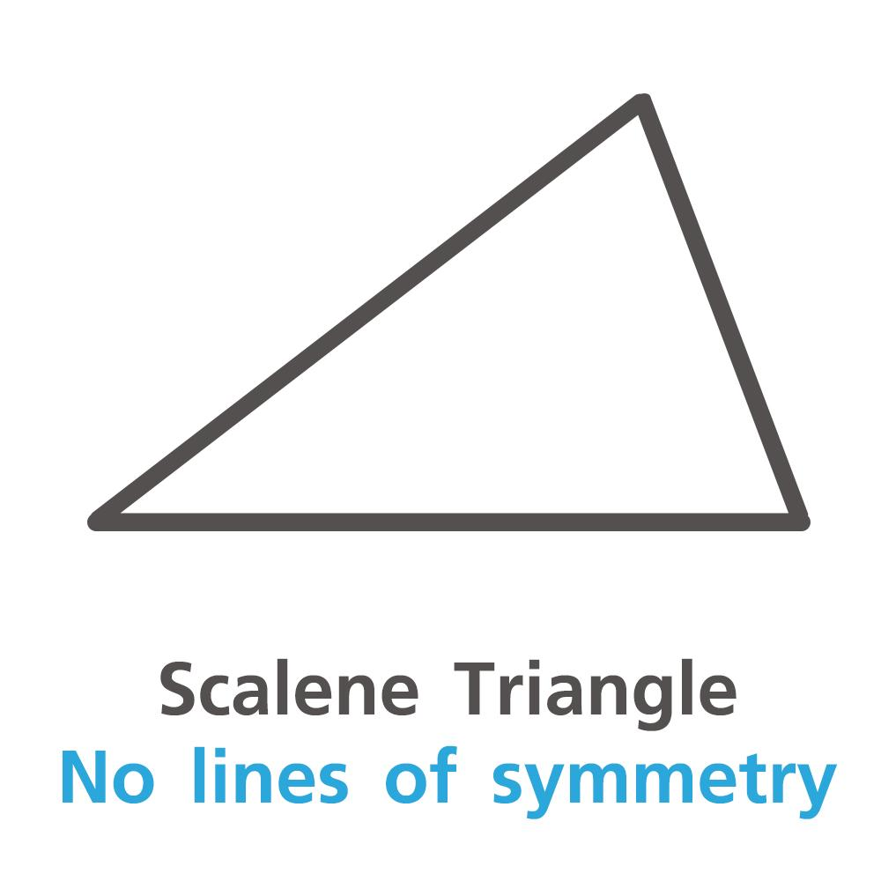
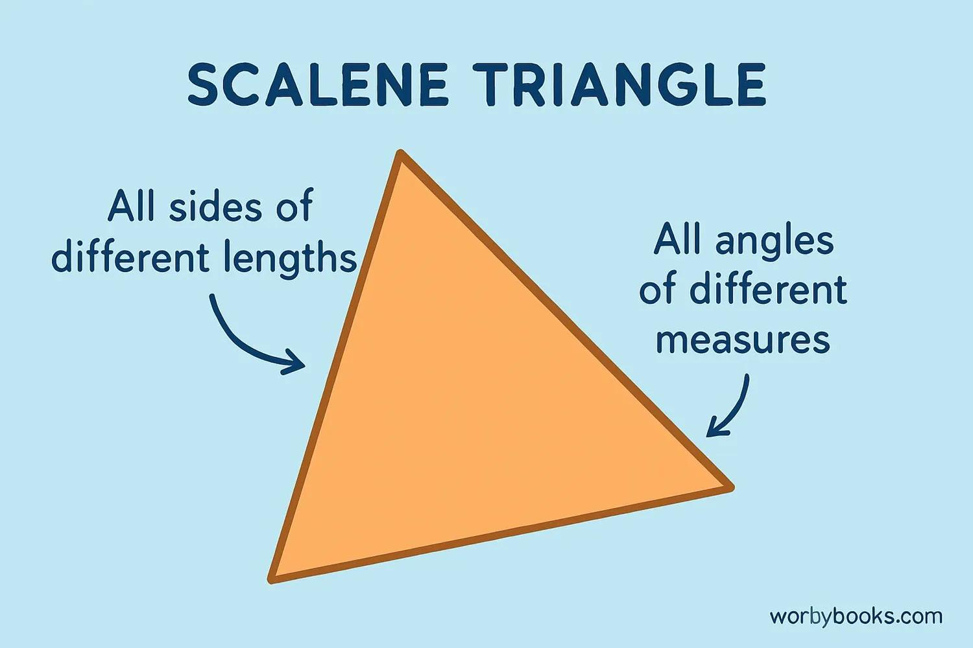
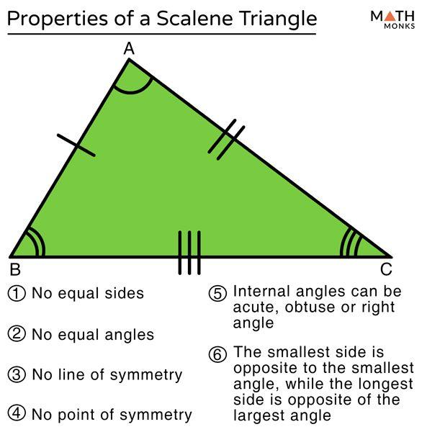
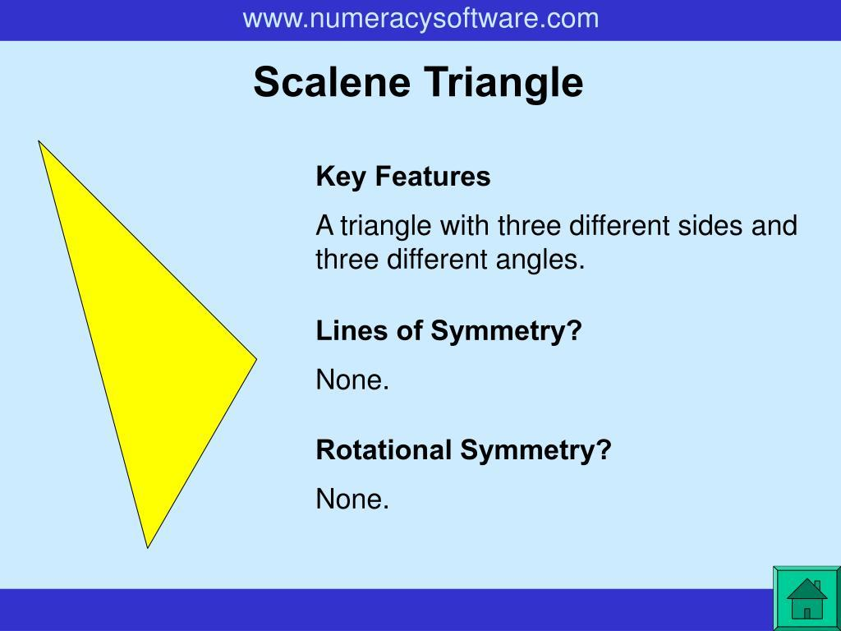

2-Rotation-Asymmetric Shapes
# Source: AI Source: Provided by: [Data Path: Persons Table -> ID Column: 1, Name_En Column: Motasem Essam] -> From: [ChatGPT] on [7/25/2026]
A shape has rotational asymmetry when no rotation smaller than ${360}^{∘}$maps it onto itself.
For example, a general scalene triangle has rotational symmetry of order $1$only.

3-Point-Asymmetric Shapes
# Source: AI Source: Provided by: [Data Path: Persons Table -> ID Column: 1, Name_En Column: Motasem Essam] -> From: [ChatGPT] on [7/25/2026]
A shape without point symmetry does not remain unchanged under a ${180}^{∘}$rotation about any point.
For example, a general triangle does not have point symmetry.

4-Completely Asymmetric Shapes
# Source: AI Source: Provided by: [Data Path: Persons Table -> ID Column: 1, Name_En Column: Motasem Essam] -> From: [ChatGPT] on [7/25/2026]
A completely asymmetric shape has none of the commonly considered non-trivial symmetries:
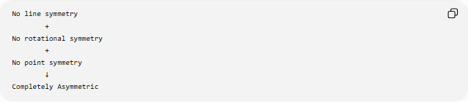
No line symmetry
+
No rotational symmetry
+
No point symmetry
↓
Completely Asymmetric
A randomly shaped irregular polygon or freeform shape can have this property.

Asymmetric Geometric Shapes
# Source: AI Source: Provided by: [Data Path: Persons Table -> ID Column: 1, Name_En Column: Motasem Essam] -> From: [ChatGPT] on [7/25/2026]
Asymmetry can occur in ordinary geometric shapes.
Examples include:
Scalene Triangle
A scalene triangle has three unequal sides:
$$a≠b, b≠c, a≠c$$
It has:
- 0 lines of symmetry
- Rotational order 1
- No point symmetry
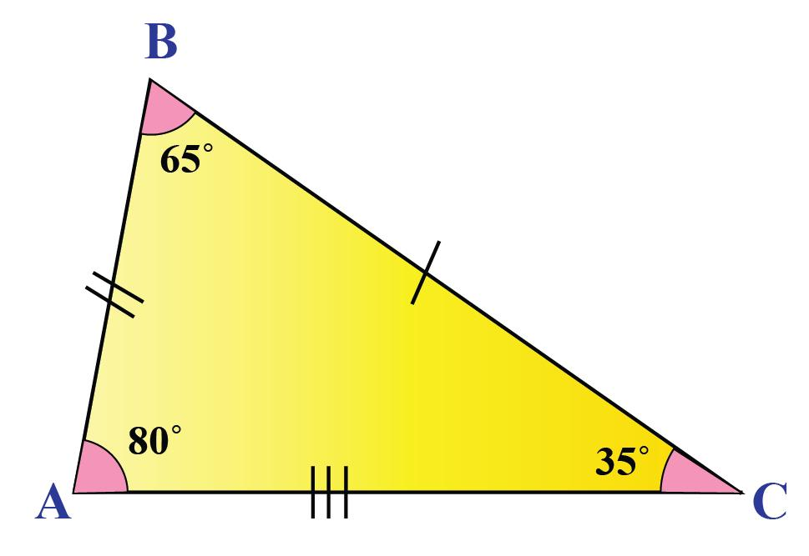
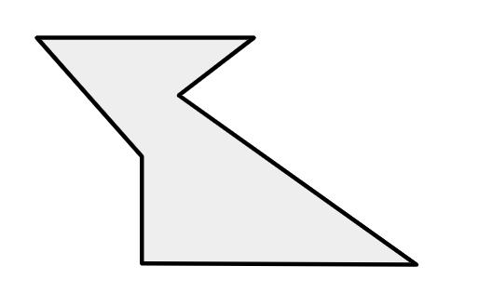
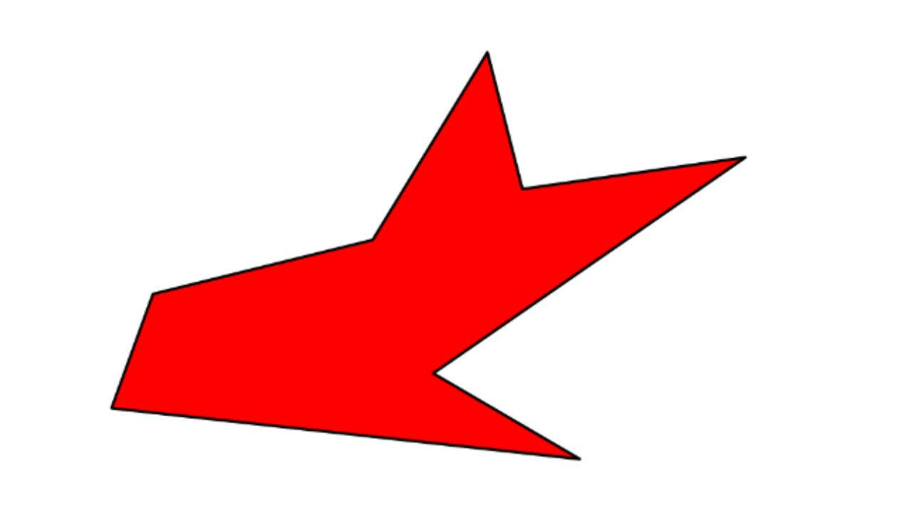
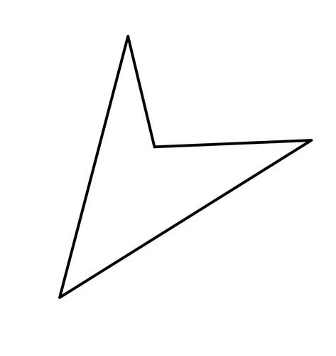
Irregular Polygon
An irregular polygon can have:
- Unequal side lengths
- Unequal angles
- No line symmetry
- No rotational symmetry other than the trivial ${360}^{∘}$rotation

Asymmetric Organic Shapes
# Source: AI Source: Provided by: [Data Path: Persons Table -> ID Column: 1, Name_En Column: Motasem Essam] -> From: [ChatGPT] on [7/25/2026]
Many natural forms are approximately asymmetric.
Examples include:
- Irregular leaves
- Tree branches
- Rocks
- Clouds
- Natural splashes
- Animal silhouettes
- Natural terrain

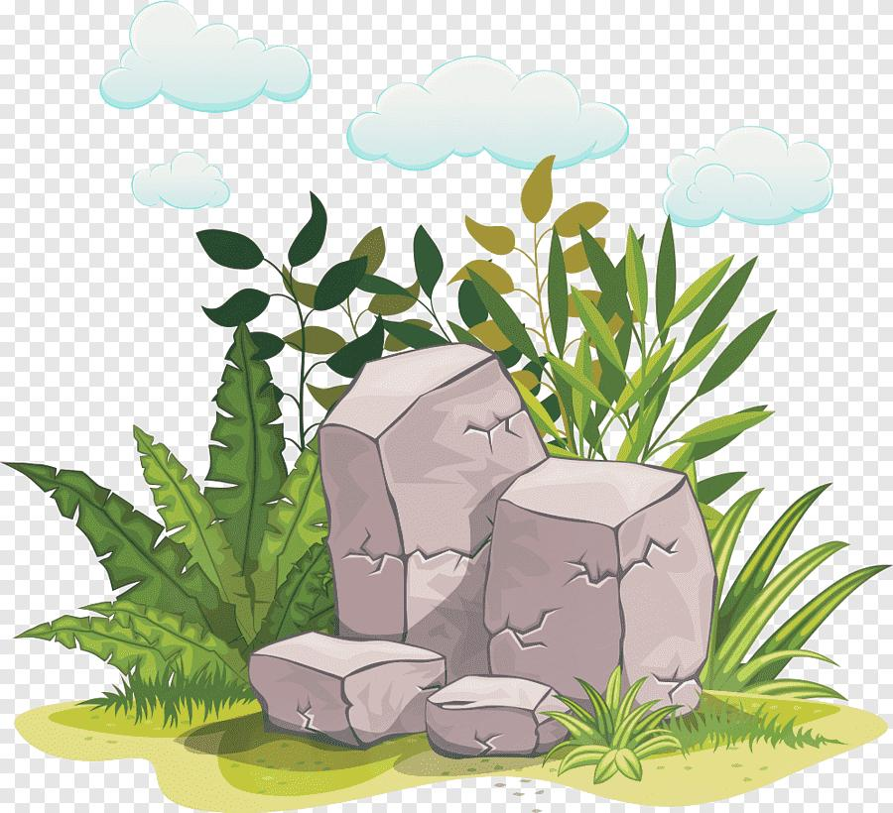


Natural asymmetry does not necessarily mean that every measurement is different. It means that the overall shape lacks the relevant symmetry.

Asymmetric Freeform Shapes
# Source: AI Source: Provided by: [Data Path: Persons Table -> ID Column: 1, Name_En Column: Motasem Essam] -> From: [ChatGPT] on [7/25/2026]
Freeform shapes frequently exhibit asymmetry because their boundaries are not constrained by a fixed geometric pattern.
For example:
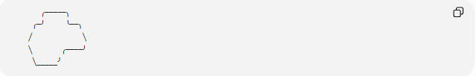
╭─────╮
╭─╯ ╰──╮
╱ ╲
╲ ╭────╯
╲_____╯
The different sides do not correspond as mirror images.

Asymmetric vs Symmetric Shapes
# Source: AI Source: Provided by: [Data Path: Persons Table -> ID Column: 1, Name_En Column: Motasem Essam] -> From: [ChatGPT] on [7/25/2026]
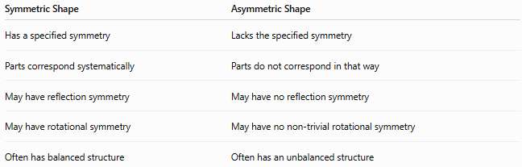
Symmetric Shape | Asymmetric Shape
Has a specified symmetry | Lacks the specified symmetry
Parts correspond systematically | Parts do not correspond in that way
May have reflection symmetry | May have no reflection symmetry
May have rotational symmetry | May have no non-trivial rotational symmetry
Often has balanced structure | Often has an unbalanced structure
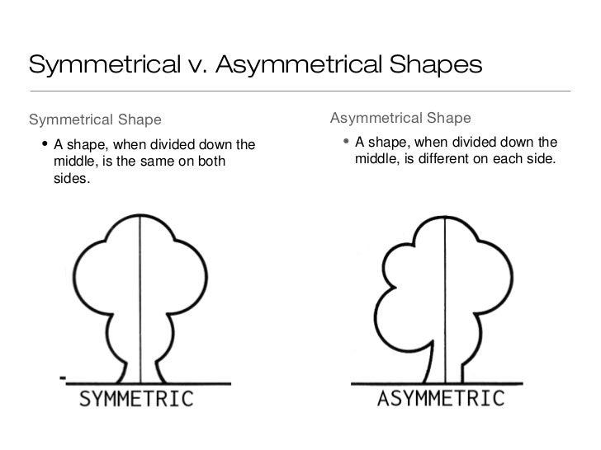
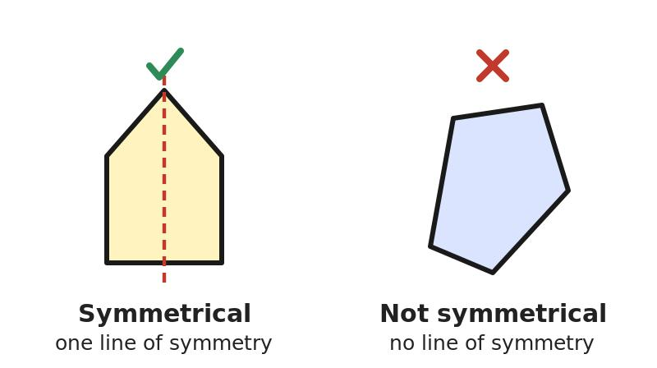
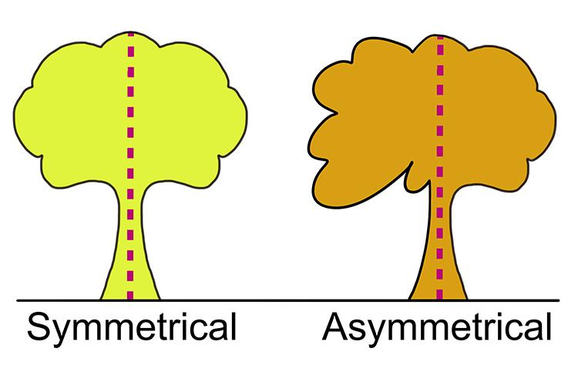

Asymmetric vs Irregular Shapes
# Source: AI Source: Provided by: [Data Path: Persons Table -> ID Column: 1, Name_En Column: Motasem Essam] -> From: [ChatGPT] on [7/25/2026]
These terms are related but not identical.
An irregular shape does not satisfy the defining conditions of a regular shape.
An asymmetric shape lacks a specified symmetry.
Therefore:
$$\boxed{\text{Irregular}≠\text{Asymmetric}}$$
For example, a rectangle that is not a square is irregular as a polygon but still has two lines of symmetry.
Conversely, some non-regular shapes can still possess symmetry.

Asymmetric vs Freeform Shapes
# Source: AI Source: Provided by: [Data Path: Persons Table -> ID Column: 1, Name_En Column: Motasem Essam] -> From: [ChatGPT] on [7/25/2026]
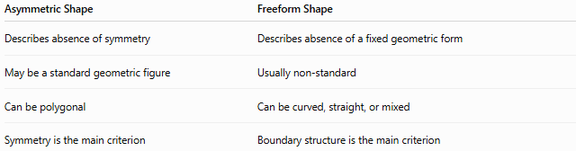
Asymmetric Shape | Freeform Shape
Describes absence of symmetry | Describes absence of a fixed geometric form
May be a standard geometric figure | Usually non-standard
Can be polygonal | Can be curved, straight, or mixed
Symmetry is the main criterion | Boundary structure is the main criterion
A shape can therefore be:
$$\boxed{\text{Freeform + Asymmetric}}$$
but it does not have to be.

Mathematical Perspective
# Source: AI Source: Provided by: [Data Path: Persons Table -> ID Column: 1, Name_En Column: Motasem Essam] -> From: [ChatGPT] on [7/25/2026]
Symmetry can be expressed through transformations.
For reflection symmetry, a reflection transformation $R$satisfies:
$$R\left(S\right)=S$$
where $S$represents the shape.
For rotational symmetry, a rotation $T_{θ}$satisfies:
$$T_{θ}\left(S\right)=S$$
for some angle:
$$0^{∘}<θ<{360}^{∘}$$
An asymmetric shape does not satisfy the relevant non-trivial symmetry condition.
For example, if no non-trivial rotation maps the shape onto itself:
$$\boxed{T_{θ}\left(S\right)≠S}$$
for all:
$$0^{∘}<θ<{360}^{∘}$$

Classification Summary
# Source: AI Source: Provided by: [Data Path: Persons Table -> ID Column: 1, Name_En Column: Motasem Essam] -> From: [ChatGPT] on [7/25/2026]
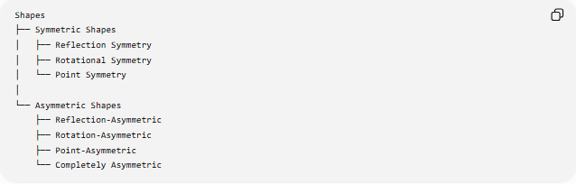
Shapes
├── Symmetric Shapes
│ ├── Reflection Symmetry
│ ├── Rotational Symmetry
│ └── Point Symmetry
│
└── Asymmetric Shapes
├── Reflection-Asymmetric
├── Rotation-Asymmetric
├── Point-Asymmetric
└── Completely Asymmetric
Another useful classification is:
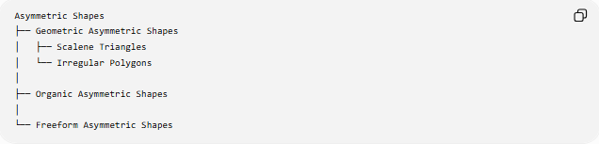
Asymmetric Shapes
├── Geometric Asymmetric Shapes
│ ├── Scalene Triangles
│ └── Irregular Polygons
│
├── Organic Asymmetric Shapes
│
└── Freeform Asymmetric Shapes

Examples
# Source: AI Source: Provided by: [Data Path: Persons Table -> ID Column: 1, Name_En Column: Motasem Essam] -> From: [ChatGPT] on [7/25/2026]
Common examples include:
- Scalene triangles
- Irregular polygons
- Irregular quadrilaterals
- Asymmetric stars
- Abstract freeform shapes
- Irregular blobs
- Natural rocks
- Uneven leaves
- Irregular clouds
- Asymmetric artistic forms
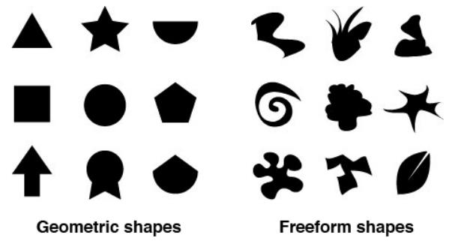
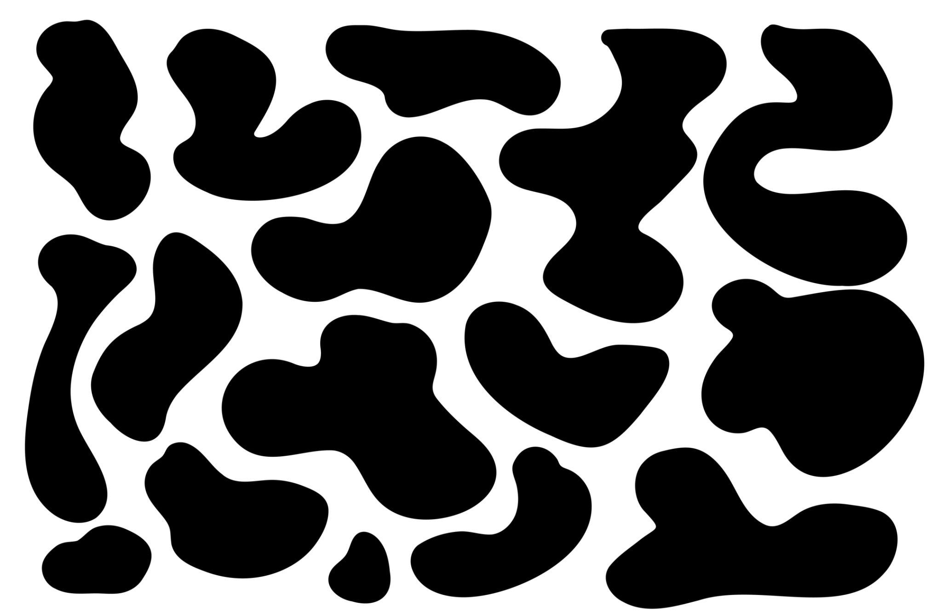
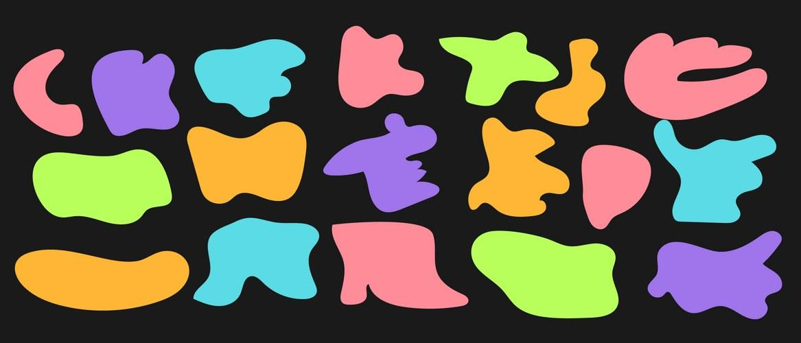
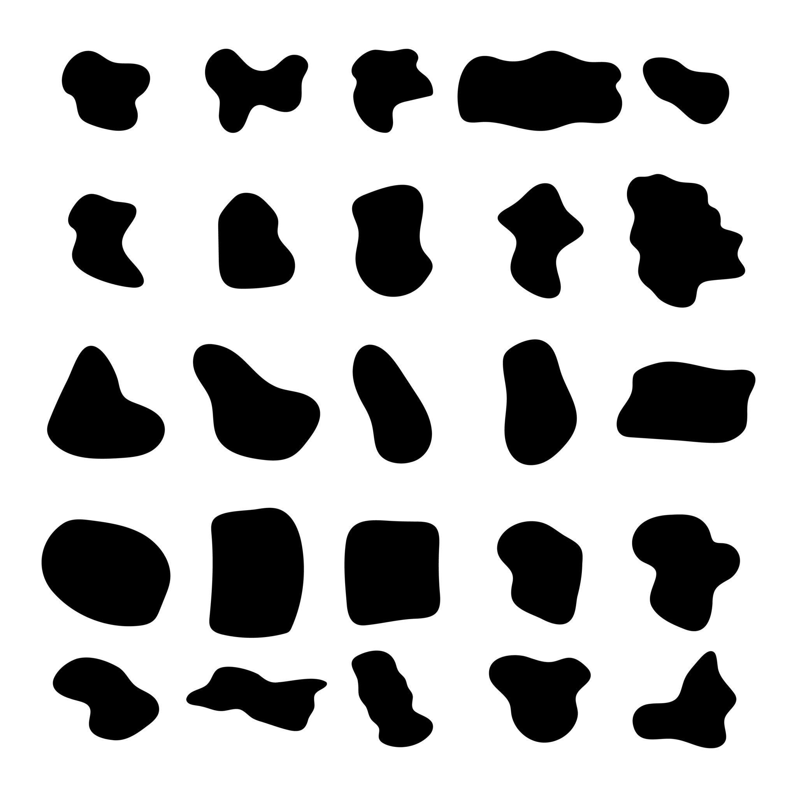

Key Points
# Source: AI Source: Provided by: [Data Path: Persons Table -> ID Column: 1, Name_En Column: Motasem Essam] -> From: [ChatGPT] on [7/25/2026]
- An Asymmetric Shape lacks the symmetry being considered.
- It may have no line symmetry.
- It may have no non-trivial rotational symmetry.
- It may lack point symmetry.
- A shape can be asymmetric with respect to one transformation while symmetric with respect to another.
- Asymmetric does not mean the same thing as irregular.
- Asymmetric describes symmetry, while freeform describes geometric structure.
- Geometric, organic, and freeform shapes can all be asymmetric.
- A scalene triangle is a simple example of a shape with no line symmetry.

Conclusion
# Source: AI Source: Provided by: [Data Path: Persons Table -> ID Column: 1, Name_En Column: Motasem Essam] -> From: [ChatGPT] on [7/25/2026]
An Asymmetric Shape is a shape that lacks the specified symmetry transformation. It may have an unbalanced arrangement of sides, angles, curves, or other features. Asymmetry can occur in geometric, organic, and freeform shapes, making it a property that can be used across many different shape classifications.

